# Quartz liner set 2: 2021 April 1 - 7 May

**1 April 2021:** Davis > Project >  **Luuk\_Prj\_Type=Piv\_Date=20210401\_Time=122635\_trial\_1**

**16 April 2021:** Davis > Project > **Luuk\_Prj\_Type=Piv\_Date=20210416\_Time=140128\_trial\_2**

**30 April 2021:** Davis > Project > **Luuk\_Prj\_Type=Piv\_Date=20210430\_Time=104353\_1024x1024**, **Luuk\_Prj\_Type=Piv\_Date=20210430\_Time=160136\_768x768**

3 May 2021

**Uit PIV metingen bleek, dat de seeding density niet goed was: weinig seeding aan de liner wall en veel seeding in de core -> Brander open maken en schoonmaken.  
  
Het resultaat van het open maken van de brander -> ophoping van seeding!**

Note: Bij 2 runs is de volledige brander volgelopen met seeding particles, als gevolg van het afstellen van de seeder.

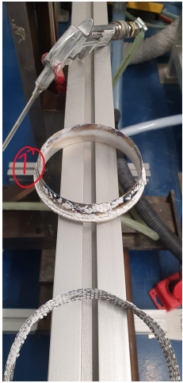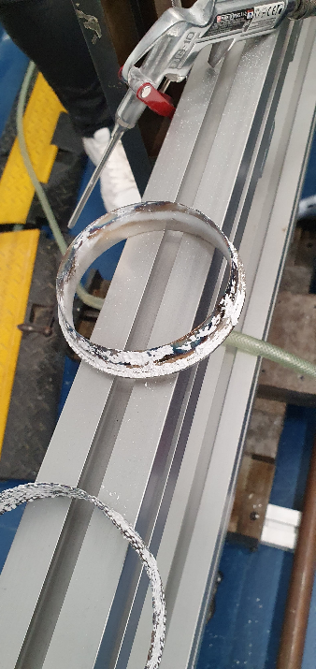

C:\Users\laaltenburg\AppData\Local\Microsoft\Windows\INetCache\Content.MSO\4808B67C.tmp

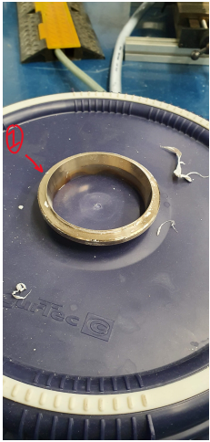

|  |  |  |  |  |  |
| --- | --- | --- | --- | --- | --- |
|  |  |  |  |  |  |
|  | C:\Users\laaltenburg\AppData\Local\Microsoft\Windows\INetCache\Content.MSO\BE8E6DEA.tmp |  |  |  | C:\Users\laaltenburg\AppData\Local\Microsoft\Windows\INetCache\Content.MSO\680F34D6.tmp |

C:\Users\laaltenburg\AppData\Local\Microsoft\Windows\INetCache\Content.MSO\F1F02F54.tmp

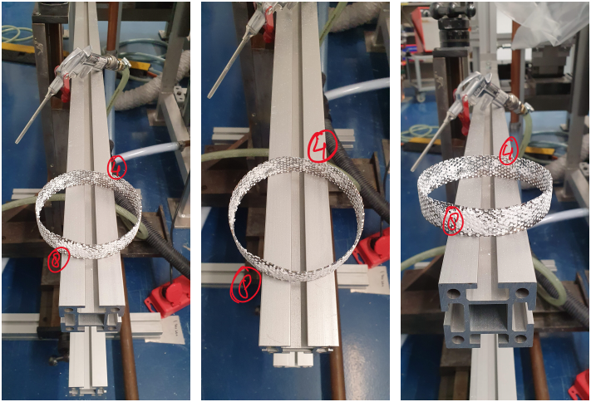



|  |  |  |  |  |  |
| --- | --- | --- | --- | --- | --- |
|  |  |  |  |  |  |
|  | .  ٠ |  | C:\Users\LAALTE~1\AppData\Local\Temp\msohtmlclip1\02\clip_image003.pngC:\Users\LAALTE~1\AppData\Local\Temp\msohtmlclip1\02\clip_image002.pngC:\Users\LAALTE~1\AppData\Local\Temp\msohtmlclip1\02\clip_image002.png | | | |
| C:\Users\LAALTE~1\AppData\Local\Temp\msohtmlclip1\02\clip_image001.png |  |  |
|  |  |  |  |  |  |

|  |  |  |  |  |  |
| --- | --- | --- | --- | --- | --- |
|  | 6 May 2021 |  |  |  |  |

7 May 2021

**Metingen voor Hgv:**

|  |  |  |  |
| --- | --- | --- | --- |
|  | **Mixer 2** | **Mixer 6** | **Mixer 8** |
| **Hm\* [mm]** | 142.2 | 142.6 | 142.0 |
| **H\_gap [mm]** | 1.60 | 1.15 | 1.15 |

**Project Davis:  
Luuk\_Prj\_Type=Piv\_Date=20210507\_Time=105410\_trial\_4**

**Main settings:**

Image rate = 1 kHz

**Runs:**

|  |  |  |  |  |  |  |  |
| --- | --- | --- | --- | --- | --- | --- | --- |
| **Run** | Data set name in Davis | Position seeder | dt | f# | Image rate [kHz] | Laser current | PIV |
| **Run 1** | Cam\_Date=210507\_Time=114607\_run1 | Rechtop, bypass bijna dicht, seed channel open | 50 | 16 | 1 | 18.3A / 17.3A | Double frame |
| **Run 2** | Cam\_Date=210507\_Time=\_run2 |  |  |  |  |  |  |
| **Run 3** | Cam\_Date=210507\_Time=\_run3 |  |  |  |  |  |  |

**Notes:**